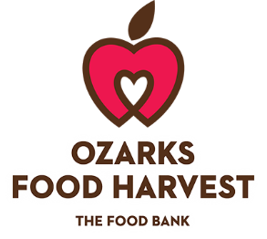

Bequest Language
In order to make a bequest you should speak with your attorney. Your attorney can help you include a bequest to Ozarks in your estate plan. We have provided some basic bequest language to assist you and your attorney.
Specific Bequest
If you are considering making an outright bequest to Ozarks Food Harvest, we recommend the following language:
Bequest of a Specific Dollar Amount
I hereby give, devise and bequeath ___________ and No/100 dollars ($DOLLARS) to Ozarks Food Harvest, a nonprofit organization located at 2810 N. Cedarbrook, Springfield, MO 65803, Federal Tax ID #43-1426384, for Ozarks Food Harvest’s general use and purpose.

Bequest of a Specific Personal Property
I hereby give, devise and bequeath DESCRIPTION OF PROPERTY to Ozarks Food Harvest, a nonprofit organization located at 2810 N. Cedarbrook, Springfield, MO 65803, Federal Tax ID #43-1426384, for Ozarks Food Harvest’s general use and purpose.

Bequest of a Specific Real Estate
I hereby give, devise and bequeath all of the right, title and interest in and to the real estate located at ADDRESS OR DESCRIPTION OF PROPERTY to Ozarks Food Harvest, a nonprofit organization located at 2810 N. Cedarbrook, Springfield, MO 65803, Federal Tax ID #43-1426384, for Ozarks Food Harvest’s general use and purpose.

Percentage Bequest
If you are considering making a bequest of a percentage of your estate to Ozarks Food Harvest, we recommend the following language:
I hereby give, devise and bequeath ____ percent (____%) of my total estate, determined as of the date of my death, to Ozarks Food Harvest, a nonprofit organization located at 2810 N. Cedarbrook, Springfield, MO 65803, Federal Tax ID #43-1426384, for Ozarks Food Harvest’s general use and purpose.

Residential Bequest
I hereby give, devise and bequeath to Ozarks Food Harvest, a nonprofit organization located at 2810 N. Cedarbrook, Springfield, MO 65803, Federal Tax ID #43-1426384, ALL OR A PERCENTAGE of the rest, residue and remainder of my estate to be used for Ozarks Food Harvest’s general use and purpose.

Contingent Bequest
If (primary beneficiary) does not survive me, then I hereby give, devise and bequeath to Ozarks Food Harvest, a nonprofit organization located at 2810 N. Cedarbrook, Springfield, MO 65803, Federal Tax ID #43-1426384, DESCRIPTION OF PROPERTY to be used for Ozarks Food Harvest’s general use and purpose.

