Items Requested | Number of Items  (Link included) | Cost per Item | Total Cost
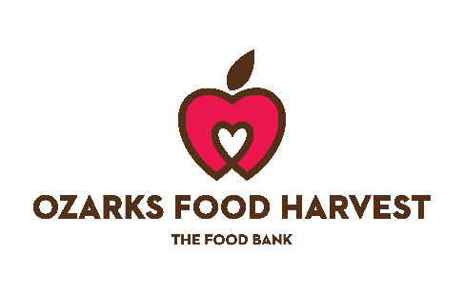

FY26 Garden Mini-Grant Budget Proposal

